
Faculty of Science

Course: CSCI 2020u – Software System Development & Integration
Component: Assignment
Weight: 10%
Deadline: March 6, 2019 (due by 11:59pm)

Collaboration Policy
You are permitted to work on this assignment in a team, and submit the results as a team. For this sort of assignment, with an open-ended component, the collaboration between multiple team members can be beneficial. Between groups, however, please limit the discussion to the level of general strategy (not code). Groups of size 2 are recommended. Larger groups will be considered with the proviso that the marker will mark your assignment with higher expectations. In any case, be sure that all members of the team fully understand all code, otherwise they will miss intended learning objectives, which may be a considerable disadvantage at exam time.

How to Submit
You will maintain a git repository for this assignment, which is a public repository. To submit the assignment, create a single file ‘README.txt’ that contains instructions on how to download, compile, and run your codes for each question. A .zip, .7z, or .rar file will not be acceptable. Also submit this word file (once you complete) into related drop box on Blackboard before deadline.

Note: Comments are mandatory. Failure to properly document your program will result in a deduction on the marks you receive for this (and any other) assignment.

Remember:
You need to complete this file and submit it in related drop box on Blackboard, in addition to uploading your codes in your git repository, before deadline.

Question 1: Displaying Three Cards

Problem Description:
Display a frame that contains three labels. Each label displays a card, as shown in the figure below. The card image files are named 1.png, 2.png, ..., 54.png and stored in the image/card directory. All three cards are distinct and selected randomly.

The image icons can be found in the attached card folder.

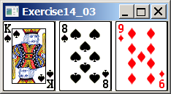

Your Task:
- Create three ImageView and set their icons using the images.
- Display three images from 54 image cards randomly.

Your Code:
Copy-paste your code here:

package csci2020.AssignmentQ1;

import javafx.application.Application;
import javafx.scene.Scene;
import javafx.scene.image.Image;
import javafx.scene.image.ImageView;
import javafx.scene.layout.HBox;
import javafx.stage.Stage;
import java.util.Random;

/**
* This program displays three random unique cards out of the 54 in a regular card deck in JavaFX.
* @author Gage Adam
* @author Geerthan Srikantharajah
*/

public class Main extends Application {

public void start(Stage primaryStage) {

primaryStage.setTitle("Question_1");

HBox hbox = new HBox(3);

//Randomly choose three cards, with ids 0-53
Random rand = new Random();
int n1 = rand.nextInt(54) + 1;
int n2 = rand.nextInt(54) + 1;
int n3 = rand.nextInt(54) + 1;

while (true)
{
if (n2 == n1)
{
n2 = rand.nextInt(53) + 1;
}
else if (n3 == n1 || n3 == n2)
{
n3 = rand.nextInt(53) + 1;
}
else
{
break;
}
}

//Read card images from file
Image card1 = new Image("file:Cards/" + n1 + ".png");
Image card2 = new Image("file:Cards/" + n2 + ".png");
Image card3 = new Image("file:Cards/" + n3 + ".png");

//Add cards to main hbox for display
hbox.getChildren().add(new ImageView(card1));
hbox.getChildren().add(new ImageView(card2));
hbox.getChildren().add(new ImageView(card3));

Scene scene = new Scene(hbox);

primaryStage.setScene(scene);
primaryStage.show();

}
public static void main(String[] args) {
launch(args);
}
}

Screen shots:
Include two screen shots here:

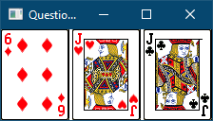

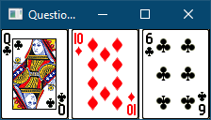

Question 2: Investment-Value calculator

Problem Description:
Write a program that calculates the future value of an investment at a given interest rate for a specified number of years. The formula for the calculation is as follows:

futureValue = investmentAmount * (1 + monthlyInterestRate)years*12

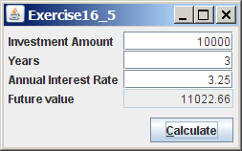

Your Task:
Use text fields for interest rate, investment amount, and years. Display the future amount in a text field when the user clicks the Calculate button, as shown in the figure.

Your Code:
Copy-paste your code here.

package csci2020.AssignmentQ2;

import javafx.application.Application;
import javafx.geometry.Insets;
import javafx.scene.Scene;
import javafx.scene.canvas.Canvas;
import javafx.scene.canvas.GraphicsContext;
import javafx.scene.layout.HBox;
import javafx.scene.layout.Pane;
import javafx.scene.paint.Color;
import javafx.scene.shape.Arc;
import javafx.scene.shape.ArcType;
import javafx.scene.text.Text;
import javafx.stage.Stage;
import javafx.application.Application;
import javafx.event.ActionEvent;
import javafx.event.EventHandler;
import javafx.geometry.HPos;
import javafx.geometry.Insets;
import javafx.scene.Scene;
import javafx.scene.control.Button;
import javafx.scene.control.Label;
import javafx.scene.control.TextField;
import javafx.scene.layout.GridPane;
import javafx.stage.Stage;

/**
* This program calculates a return on an investment given an investment amount, years invested, and an investment rate.
* @author Gage Adam
* @author Geerthan Srikantharajah
*/

public class Main extends Application {

@Override
public void start(Stage primaryStage) {

primaryStage.setTitle("Question_2");

//Pane to hold all UI elements
GridPane pane = new GridPane();
pane.setPadding(new Insets(10, 10, 10, 10));
TextField invest, years, rate, result;

pane.add(new Label("Investment Amount: "), 0, 0);
invest = new TextField();
invest.setPromptText("Amount");
pane.add(invest, 1, 0);

pane.add(new Label("Years: "), 0, 1);
years = new TextField();
years.setPromptText("Years");
pane.add(years, 1, 1);

pane.add(new Label("Annual Interest Rate: "), 0, 2);
rate = new TextField();
rate.setPromptText("Rate");
pane.add(rate, 1, 2);

pane.add(new Label("Future Value: "), 0, 3);
result = new TextField();
pane.add(result, 1, 3);
Button calculate = new Button("Calculate");

//Calculate future value from given values on button press
calculate.setOnAction(new EventHandler<ActionEvent>() {

public void handle(ActionEvent event) {
double inv = Double.valueOf(invest.getText());
double year = Double.valueOf(years.getText());
double r = Double.valueOf(rate.getText()) / 100 / 12; //Convert to monthly rate, and then to decimal (from percent)
String future;
future = String.valueOf(inv * Math.pow((1 + r), year*12)); //Future value calculation
result.setText(future);
}

});

pane.add(calculate, 1, 4);
GridPane.setHalignment(calculate, HPos.RIGHT);

Scene scene = new Scene(pane);
primaryStage.setScene(scene);
primaryStage.show();

}

public static void main(String[] args) {
launch(args);
}
}

Screen shots:
Include two screen shots here:

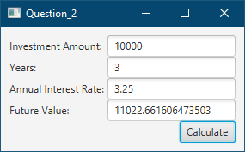

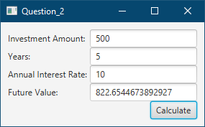

Question 3: Dragging Points on a Circle

Problem Description:
Draw a circle with three random points on the circle. Connect the points to form a triangle. Display the angles in the triangle. Use the mouse to drag a point along the perimeter of the circle. As you drag it, the triangle and angles are redisplayed dynamically.

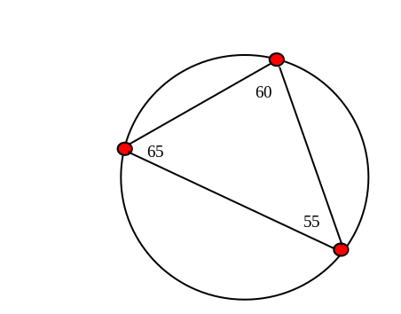

Here is the formula to compute angles:

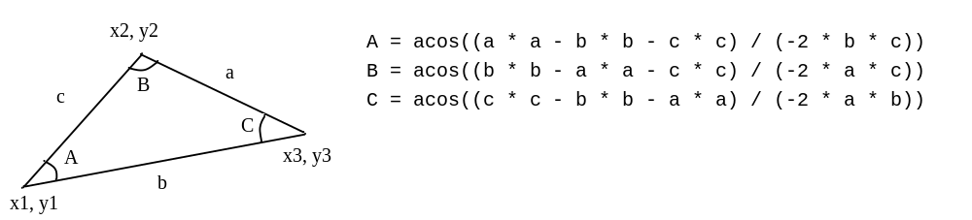

Your Code:
Copy-paste your code here:

package csci2020u_a1.Q3_PointsOnCircle;

import javafx.application.Application;
import javafx.event.EventHandler;
import javafx.geometry.Insets;
import javafx.scene.Scene;
import javafx.scene.control.Label;
import javafx.scene.input.MouseEvent;
import javafx.scene.layout.Pane;
import javafx.scene.paint.Color;
import javafx.scene.shape.Circle;
import javafx.scene.shape.Line;
import javafx.stage.Stage;

/**
* This program displays three draggable points on a circle in JavaFX.
* It then shows what triangle those points would make, as well as the internal angles for that triangle.
* @author Geerthan Srikantharajah
* @author Gage Adam
*/

public class PointsOnCircle extends Application {

Circle[] crcs;
Line ln1, ln2, ln3;
Label[] lbls;

public void start(Stage primaryStage) {

Pane p = new Pane();
p.setPadding(new Insets(10, 0, 0, 10));

//The circle that all three points must be on
Circle mainCirc = new Circle(200, 200, 190, null);
mainCirc.setStroke(Color.BLACK);

//Shows if a point is being moved by changing its color
EventHandler<MouseEvent> mousePressHandler = new EventHandler<MouseEvent>() {
public void handle(MouseEvent e) {
Circle c = (Circle)(e.getSource());
c.setFill(Color.MEDIUMSPRINGGREEN);
}
};

EventHandler<MouseEvent> mouseReleaseHandler = new EventHandler<MouseEvent>() {
public void handle(MouseEvent e) {
Circle c = (Circle)(e.getSource());
c.setFill(Color.RED);
}
};

//Moves a circle to a valid new point on the big circle, if it won't move past another small circle
EventHandler<MouseEvent> dragHandler = new EventHandler<MouseEvent>() {
public void handle(MouseEvent e) {

//Conversion to a typical cartesian coordinate system
double x = e.getSceneX() - 200;
double y = -(e.getSceneY() - 200);
double m = y/x;

//Calculates a new point on the circle
//Takes the slope from the middle of the big circle to the mouse cursor, then extends the line to a point on the big circle
double nx = (x/Math.abs(x))*190 * Math.sqrt(1 / (Math.pow(m, 2) + 1));
double ny = m * nx;

Circle c = (Circle)(e.getSource());

//Ensures that there are no collisions
if(notColliding(c, nx+200, -ny+200)) {
//Converts back to the coordinate system used by JavaFX
c.setCenterX(nx+200);
c.setCenterY(-ny+200);
}

//Updates internal angle labels
updateLabels();
}
};

//Generates three movable points on the big circle
crcs = new Circle[3];

crcs[0] = new Circle(200, 10, 8, Color.RED);
crcs[0].setStroke(Color.BLACK);
crcs[0].setOnMouseDragged(dragHandler);
crcs[0].setOnMousePressed(mousePressHandler);
crcs[0].setOnMouseReleased(mouseReleaseHandler);

crcs[1] = new Circle(390, 200, 8, Color.RED);
crcs[1].setStroke(Color.BLACK);
crcs[1].setOnMouseDragged(dragHandler);
crcs[1].setOnMousePressed(mousePressHandler);
crcs[1].setOnMouseReleased(mouseReleaseHandler);

crcs[2] = new Circle(200, 390, 8, Color.RED);
crcs[2].setStroke(Color.BLACK);
crcs[2].setOnMouseDragged(dragHandler);
crcs[2].setOnMousePressed(mousePressHandler);
crcs[2].setOnMouseReleased(mouseReleaseHandler);

//Generates three lines to make a triangle
ln1 = new Line();
ln1.startXProperty().bind(crcs[0].centerXProperty());
ln1.startYProperty().bind(crcs[0].centerYProperty());
ln1.endXProperty().bind(crcs[1].centerXProperty());
ln1.endYProperty().bind(crcs[1].centerYProperty());

ln2 = new Line();
ln2.startXProperty().bind(crcs[1].centerXProperty());
ln2.startYProperty().bind(crcs[1].centerYProperty());
ln2.endXProperty().bind(crcs[2].centerXProperty());
ln2.endYProperty().bind(crcs[2].centerYProperty());

ln3 = new Line();
ln3.startXProperty().bind(crcs[2].centerXProperty());
ln3.startYProperty().bind(crcs[2].centerYProperty());
ln3.endXProperty().bind(crcs[0].centerXProperty());
ln3.endYProperty().bind(crcs[0].centerYProperty());

//Generates three labels for internal angles on the triangle
lbls = new Label[]{new Label(), new Label(), new Label()};

updateLabels();

//Adds everything to UI
p.getChildren().addAll(mainCirc, ln1, ln2, ln3, lbls[0], lbls[1], lbls[2], crcs[0], crcs[1], crcs[2]);

Scene s = new Scene(p);
primaryStage.setTitle("Question_3");
primaryStage.setScene(s);
primaryStage.show();

}

/**
* This method updates labels for three internal angles on the displayed triangle.
*/
public void updateLabels() {

//Angle of lines 1-3, measured from the x axis upwards (like the unit circle)
double a1 = Math.toDegrees(Math.atan2(-ln1.getEndY() + ln1.getStartY(), ln1.getEndX() - ln1.getStartX()));
double a2 = Math.toDegrees(Math.atan2(-ln2.getEndY() + ln2.getStartY(), ln2.getEndX() - ln2.getStartX()));
double a3 = Math.toDegrees(Math.atan2(-ln3.getEndY() + ln3.getStartY(), ln3.getEndX() - ln3.getStartX()));

//Angle of lines 1-3 if the line was considered backwards (endpoint to start point)
double a1R = Math.toDegrees(Math.atan2(-ln1.getStartY() + ln1.getEndY(), ln1.getStartX() - ln1.getEndX()));
double a2R = Math.toDegrees(Math.atan2(-ln2.getStartY() + ln2.getEndY(), ln2.getStartX() - ln2.getEndX()));
double a3R = Math.toDegrees(Math.atan2(-ln3.getStartY() + ln3.getEndY(), ln3.getStartX() - ln3.getEndX()));

//Corrects negative angles
if(a1 < 0) a1 = 360 + a1;
if(a2 < 0) a2 = 360 + a2;
if(a3 < 0) a3 = 360 + a3;

if(a1R < 0) a1R = 360 + a1R;
if(a2R < 0) a2R = 360 + a2R;
if(a3R < 0) a3R = 360 + a3R;

//Calculates internal angles
double val0 = a1 - a3R;
double val1 = a2 - a1R;
double val2 = a3 - a2R;

//Corrects negative angles
if(val0 < 0) val0 = 360 + val0;
if(val1 < 0) val1 = 360 + val1;
if(val2 < 0) val2 = 360 + val2;

String v0Out = String.valueOf(val0);
String v1Out = String.valueOf(val1);
String v2Out = String.valueOf(val2);

//Truncates calculation for easy reading
v0Out = v0Out.substring(0, Math.min(v0Out.length(), 5));
v1Out = v1Out.substring(0, Math.min(v1Out.length(), 5));
v2Out = v2Out.substring(0, Math.min(v2Out.length(), 5));

lbls[0].setText(v0Out);
lbls[1].setText(v1Out);
lbls[2].setText(v2Out);

//Binds location to an area close to the triangle point, but biased towards the other two points slightly to estimate a good labeling position in the triangle
//Adjusts dynamically whenever the triangle moves to try and stay close
lbls[0].layoutXProperty().bind(ln1.startXProperty().add(ln1.endXProperty().subtract(ln1.startXProperty()).multiply(0.1)).add(ln3.startXProperty().subtract(ln3.endXProperty()).multiply(0.1)));
lbls[0].layoutYProperty().bind(ln1.startYProperty().add(ln1.endYProperty().subtract(ln1.startYProperty()).multiply(0.1)).add(ln3.startYProperty().subtract(ln3.endYProperty()).multiply(0.1)));

lbls[1].layoutXProperty().bind(ln2.startXProperty().add(ln2.endXProperty().subtract(ln2.startXProperty()).multiply(0.1)).add(ln1.startXProperty().subtract(ln1.endXProperty()).multiply(0.1)));
lbls[1].layoutYProperty().bind(ln2.startYProperty().add(ln2.endYProperty().subtract(ln2.startYProperty()).multiply(0.1)).add(ln1.startYProperty().subtract(ln1.endYProperty()).multiply(0.1)));

lbls[2].layoutXProperty().bind(ln3.startXProperty().add(ln3.endXProperty().subtract(ln3.startXProperty()).multiply(0.1)).add(ln2.startXProperty().subtract(ln2.endXProperty()).multiply(0.1)));
lbls[2].layoutYProperty().bind(ln3.startYProperty().add(ln3.endYProperty().subtract(ln3.startYProperty()).multiply(0.1)).add(ln2.startYProperty().subtract(ln2.endYProperty()).multiply(0.1)));

}

/**
* This method checks if moving Circle c to a new location (x, y) will move it past another circle.
* @param c A point's (Circle) original position
* @param x The x coordinate of its new position (in JavaFX's coordinate system)
* @param y The y coordinate of its new position (in JavaFX's coordinate system)
* @return True if the new position is valid, False otherwise
*/
public boolean notColliding(Circle c, double x, double y) {

Circle c1 = null, c2 = null;

//Find which of the three circles c is
for(int i = 0;i < 3;i++) {
if(c == crcs[i]) continue;
else if(c1 != null) c2 = crcs[i];
else c1 = crcs[i];
}

//theta 1-4 represent the angles of each point on the big circle, similar to a unit circle
//theta 1 and 2 represent the two circles c was not identical to (the other two points on the circle)
//theta 3 is the point passed into this method
//theta 4 is the theoretical new point checked by this method
double theta1 = Math.toDegrees(Math.atan2(-(c1.getCenterY()-200), c1.getCenterX()-200));
double theta2 = Math.toDegrees(Math.atan2(-(c2.getCenterY()-200), c2.getCenterX()-200));
double theta3 = Math.toDegrees(Math.atan2(-(c.getCenterY()-200), c.getCenterX()-200));
double theta4 = Math.toDegrees(Math.atan2(-(y-200), x-200));

//Corrects negative angles
if(theta1 < 0) theta1 = 360 + theta1;
if(theta2 < 0) theta2 = 360 + theta2;
if(theta3 < 0) theta3 = 360 + theta3;
if(theta4 < 0) theta4 = 360 + theta4;

double maxTheta = Math.max(theta1, theta2);
double minTheta = Math.min(theta1, theta2);

//Makes a slight buffer next to each point
double maxThetaHi = maxTheta+4;
double maxThetaLo = maxTheta-4;
double minThetaHi = minTheta+4;
double minThetaLo = minTheta-4;

//NaN is not a valid number to base a collision off of
if(Double.isNaN(theta4)) return false;

//If the point is within angles c1/c2 and the new point is not, return False
//This means the new point is trying to get past one of the two other points
if(theta3 > minThetaHi && theta3 < maxThetaLo && (theta4 < minThetaHi || theta4 > maxThetaLo)) return false;

//Likewise, if the point is not within angles c1/c2 and the new point is, return False
if((theta3 < minThetaLo || theta3 > maxThetaHi) && theta4 > minThetaLo && theta4 < maxThetaHi) return false;

//Otherwise this new point is valid
return true;
}

public static void main(String[] args) {
launch(args);
}

}

Screen shots:
Include two screen shots here:

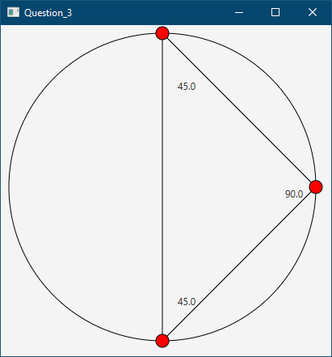

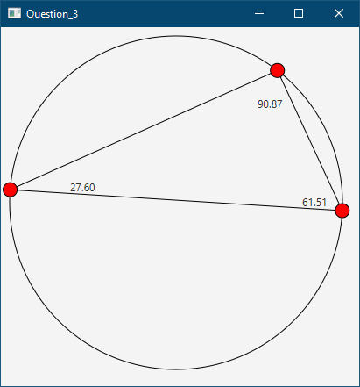

Question 4: Histogram

Problem Description:
Develop a program that displays a histogram to show the occurrences of each letter in a text area. The histogram should show the occurrences of each letter in a text file, as shown in the following figure. Assume that the letters are not case sensitive.

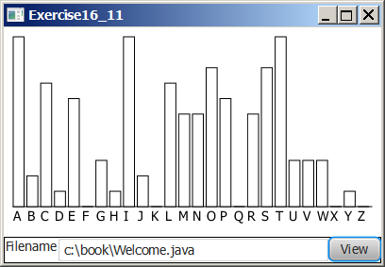

Your Task:
- Place a pane that will display the histogram in the center of the frame.
- Place a label and a text field in a panel, and put the panel in the south side of the frame. The text file will be entered from this text field.
- Pressing the Enter key on the text field causes the program to count the occurrences of each letter and display the count in a histogram.

Your Code:
Copy-paste your code here:

package csci2020u_a1.Q4_Histogram;

import java.io.File;
import java.io.FileNotFoundException;
import java.util.Scanner;

import javafx.application.Application;
import javafx.geometry.Insets;
import javafx.geometry.Pos;
import javafx.geometry.VPos;
import javafx.scene.Scene;
import javafx.scene.control.Button;
import javafx.scene.control.Label;
import javafx.scene.control.TextField;
import javafx.scene.layout.GridPane;
import javafx.scene.layout.HBox;
import javafx.scene.layout.VBox;
import javafx.scene.paint.Color;
import javafx.scene.shape.Rectangle;
import javafx.stage.Stage;

/**
* This program displays a Histogram showing character frequencies in a given text file, using JavaFX.
* @author Geerthan Srikantharajah
* @author Gage Adam
*/

public class Histogram extends Application {

Rectangle[] rects;
Label[] lbls;

public void start(Stage primaryStage) {

//The paneVBox holds all elements
VBox paneVBox = new VBox(8);
paneVBox.setPadding(new Insets(10, 10, 10, 10));

//The fileHBox holds the elements relating to filename
HBox fileHBox = new HBox();
fileHBox.setAlignment(Pos.CENTER_LEFT);

//The chartGrid GridPane holds the actual histogram
GridPane chartGrid = new GridPane();
chartGrid.setHgap(5);

rects = new Rectangle[26];
lbls = new Label[26];

//Generate a default histogram
for(int i = 0;i < 26;i++) {
rects[i] = new Rectangle(8, 50);
rects[i].setFill(null);
rects[i].setStroke(Color.BLACK);

//Add labels for each character
lbls[i] = new Label(String.valueOf((char)(65+i)));

chartGrid.add(rects[i], i, 0);
chartGrid.add(lbls[i], i, 1);

//Bottom align all bars in the histogram during generation
GridPane.setValignment(rects[i], VPos.BOTTOM);
}

Label lblFile = new Label("Filename");

TextField txtfdFilename = new TextField();
txtfdFilename.setPrefWidth(270);

Button btViewGraph = new Button("View");

//Read file listed in TextField, update histogram
btViewGraph.setOnAction(e -> {

for(int i = 0;i < 26;i++) {
rects[i].setHeight(0);
}

Scanner in;

try {
in = new Scanner(new File(txtfdFilename.getText()));
String str;

while(in.hasNext()) {
str = in.next();
for(int i = 0;i < str.length();i++) {
short idx = (short) Character.toUpperCase(str.charAt(i));

//Use ASCII values for each character
idx -= 65;

//Use rectangle data as height counter, increment when new char is found
if(idx >= 0 && idx < 26) rects[idx].setHeight(rects[idx].getHeight() + 5);
}
}

//Update window size if necessary
primaryStage.sizeToScene();

} catch (FileNotFoundException e1) {
e1.printStackTrace();
}
});

fileHBox.getChildren().addAll(lblFile, txtfdFilename, btViewGraph);

paneVBox.getChildren().addAll(chartGrid, fileHBox);

Scene s = new Scene(paneVBox);

primaryStage.setTitle("Question_4");
primaryStage.setScene(s);
primaryStage.show();

}

public static void main(String[] args) {
launch(args);
}

}

Screen shots:
Include two screen shots here:

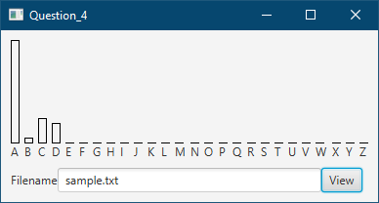

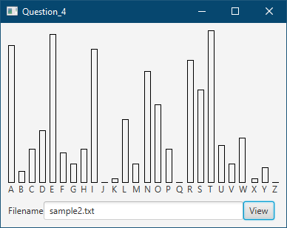

Remember:

You need to complete this file and submit it in related drop box on Blackboard, in addition to uploading your codes in your git repository, before deadline.

